Lesson Plan Generator

Home Page (lesson_planner_p1.html):

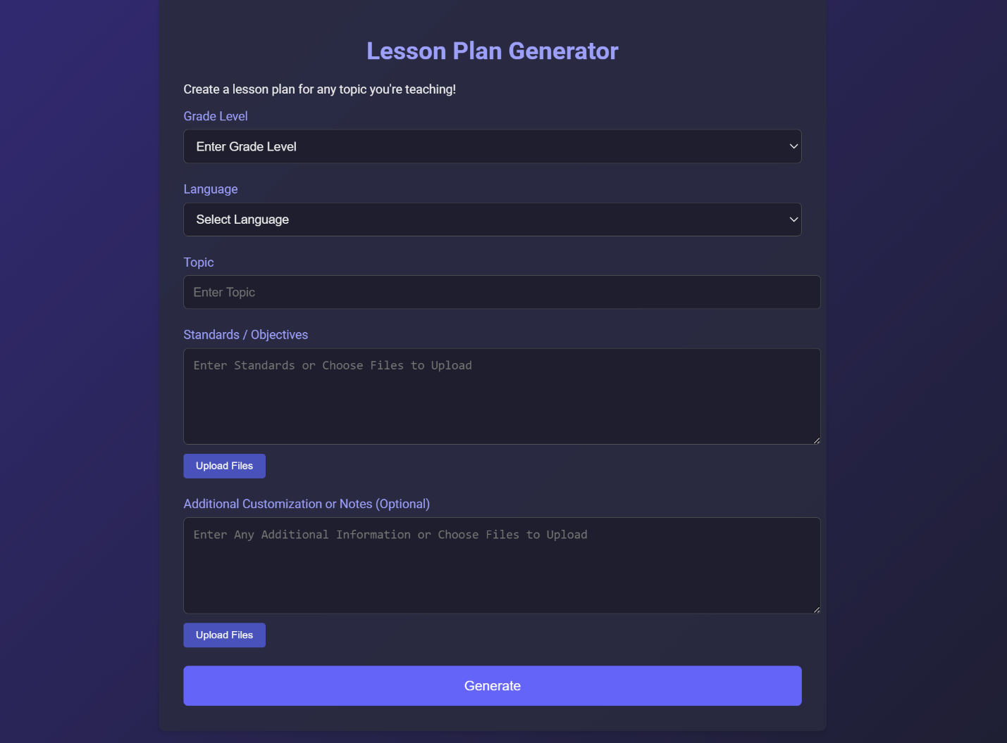

Users select the intended **Grade Level**

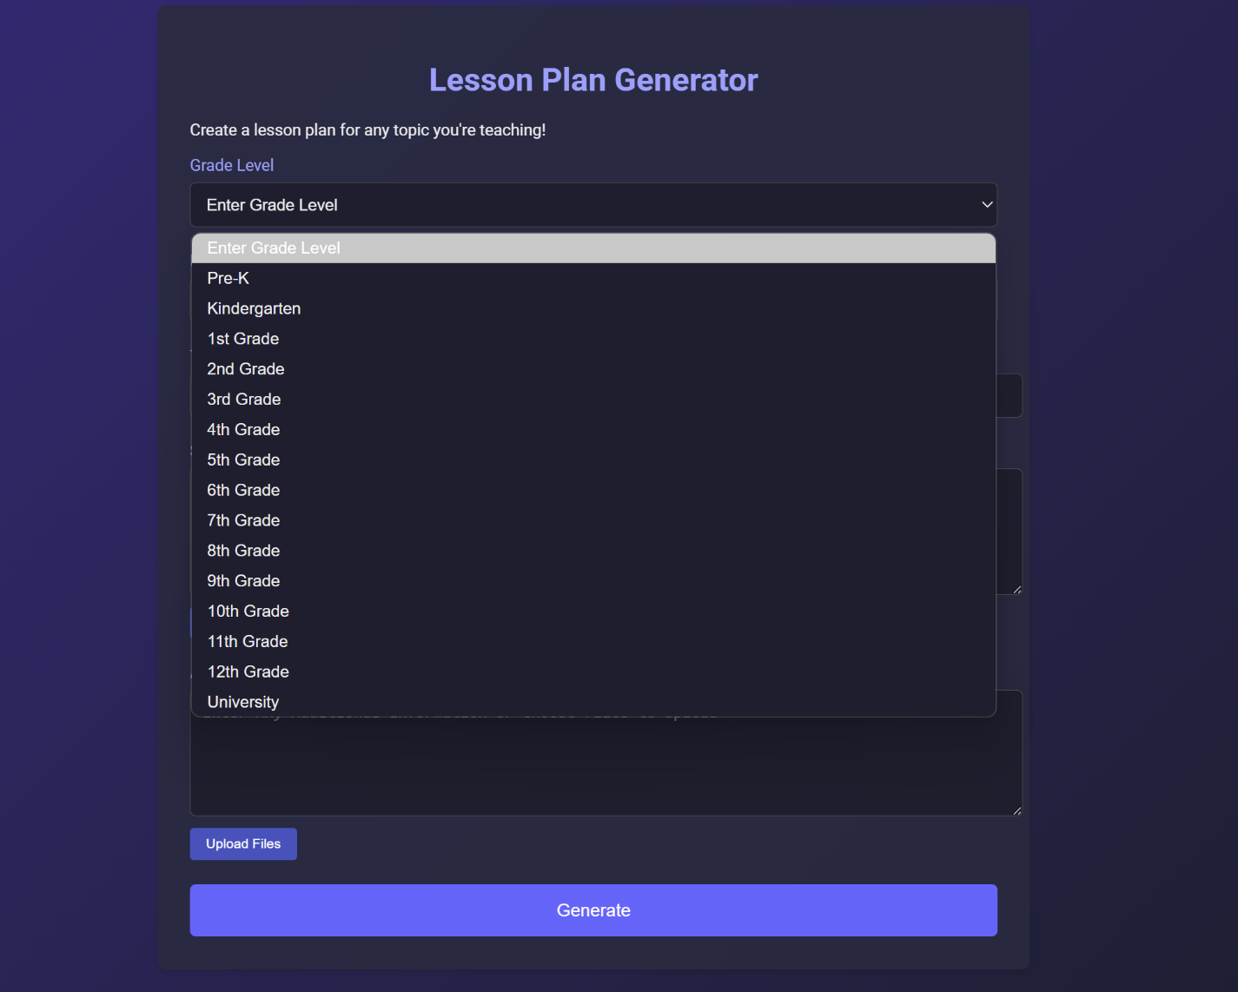

Users select the **Language** to generate the lesson in

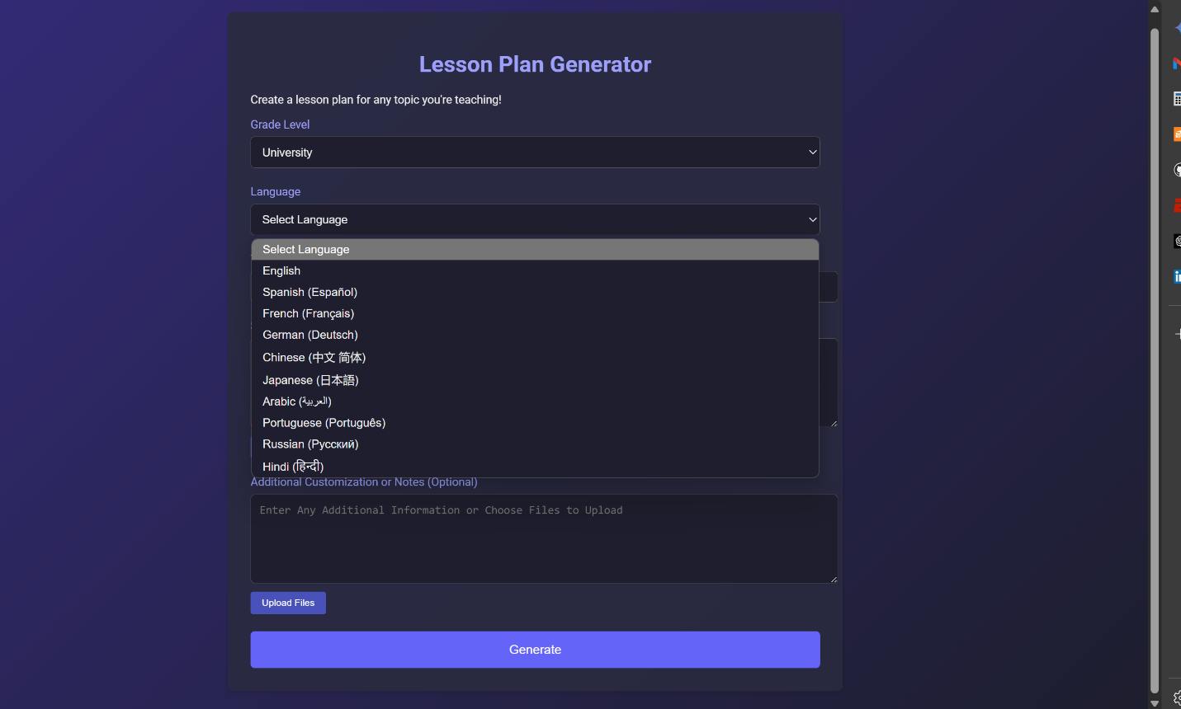

Users input the **Topic** name

Users can the **Standards/Objectives** by:

* Providing direct text input
* Selecting a file in following formats:
  + PDF, DOC, DOCX, PPTX
  + CSV
  + Google Sheets
  + Youtube video URL
  + Website URL

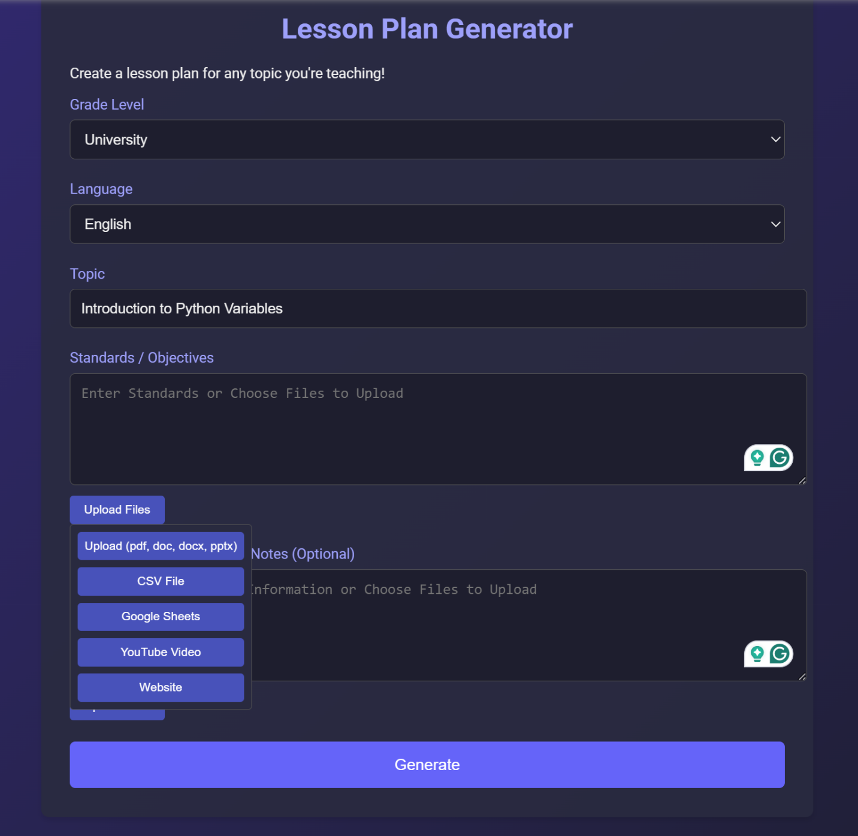

PDF File: “CS101_Introduction_to_Python_Variables.pdf”

Users can optionally include **Additional Customizations or Notes** by:

* Providing direct text input
* Selecting a file in following formats:
  + PDF, DOC, DOCX, PPTX
  + CSV
  + Google Sheets
  + Youtube video URL
  + Website URL

Direct text provided: “**Ensure a consistent naming convention**”

Generated lesson plan (**lesson_planner_p2.html**)

* The **lesson_planner_p2.html** page dynamically loads and formats lesson plan content based on user inputs from the previous page, **lesson_planner_p1.html**.
  + **Parameter Extraction**
    - The system retrieves lesson plan data from URL parameters using URLSearchParams, parses the JSON data containing grade level, topic, standards, customization, and language preferences, and passes this data from the first page when the user submits the form.
  + **Content Generation Logic**
    - The generateLessonPlanContent() function inside lesson_plan_p2.js is the core engine that creates the lesson plan. It analyzes the input parameters to determine what type of content to generate and detects specific keywords in the topic (e.g., "Python" and "variable") to generate specialized content.
  + **Content Creation**
    - For recognized topics (like Python variables), the system generates highly specific content, while for other topics, it creates generic but customizable templates that incorporate the provided topic name.
* Sections include:
  + **Topic Name**
    - Name of the lesson topic
  + **Objective**
    - This section outlines the specific learning goals students should achieve by the end of the lesson. It uses clear, measurable action verbs (define, identify, demonstrate, write) to describe what students will be able to do regarding Python variables.
  + **Key Points**
    - This section summarizes the essential concepts and information students need to understand about variables in Python. It includes definitions, technical information about data types, naming conventions, and fundamental concepts like dynamic typing that are core to the lesson.
  + **Assessment**
    - This section details how student learning will be evaluated, using multiple assessment methods: formative (during-class exercises), summative (final programming task), self-assessment, and peer assessment. This provides a comprehensive approach to measuring student understanding.
  + **Opening** 
    - This section describes how to begin the lesson to engage students' interest and activate prior knowledge. It includes an attention-grabbing activity, connects to students' existing knowledge, and clearly communicates learning targets and success criteria.
  + **Introduction to New Material**
    - This section outlines the direct instruction portion where new concepts are presented. It includes definitions, examples of different data types, addresses common misconceptions, and incorporates visual supports to enhance understanding.
  + **Guided Practice**
    - This section details structured activities where students practice the new concepts with teacher support. It includes scaffolded activities, collaborative work, strategic questioning that progresses from basic to advanced, and provisions for immediate feedback.
  + **Independent Practice**
    - This section describes how students will apply what they've learned independently. It includes specific programming tasks, challenge extensions for advanced students, and support structures for those who need additional help.
  + **Closing**
    - This section explains how to conclude the lesson effectively by synthesizing key concepts, facilitating student reflection, connecting to future learning, and conducting a final assessment of understanding.
  + **Extensions**
    - This section provides enrichment activities for students who finish early or need additional challenges, including differentiated options for both advanced learners and those requiring additional support.
  + **Homework**
    - This section outlines assignments to be completed outside of class time, including tasks that connect learning to real-world applications and opportunities for family involvement in the learning process.
  + **Materials Needed**
    - This section lists all resources, tools, and materials required to successfully implement the lesson, including technology requirements, handouts, and reference materials.
  + **Standards Addressed**
    - This section connects the lesson content to relevant educational standards (ISTE and ACM/IEEE in this case), demonstrating how the lesson aligns with broader curriculum requirements.
  + **Additional Notes**
    - This section provides supplementary information or reminders for the teacher implementing the lesson, such as ensuring consistent naming conventions.

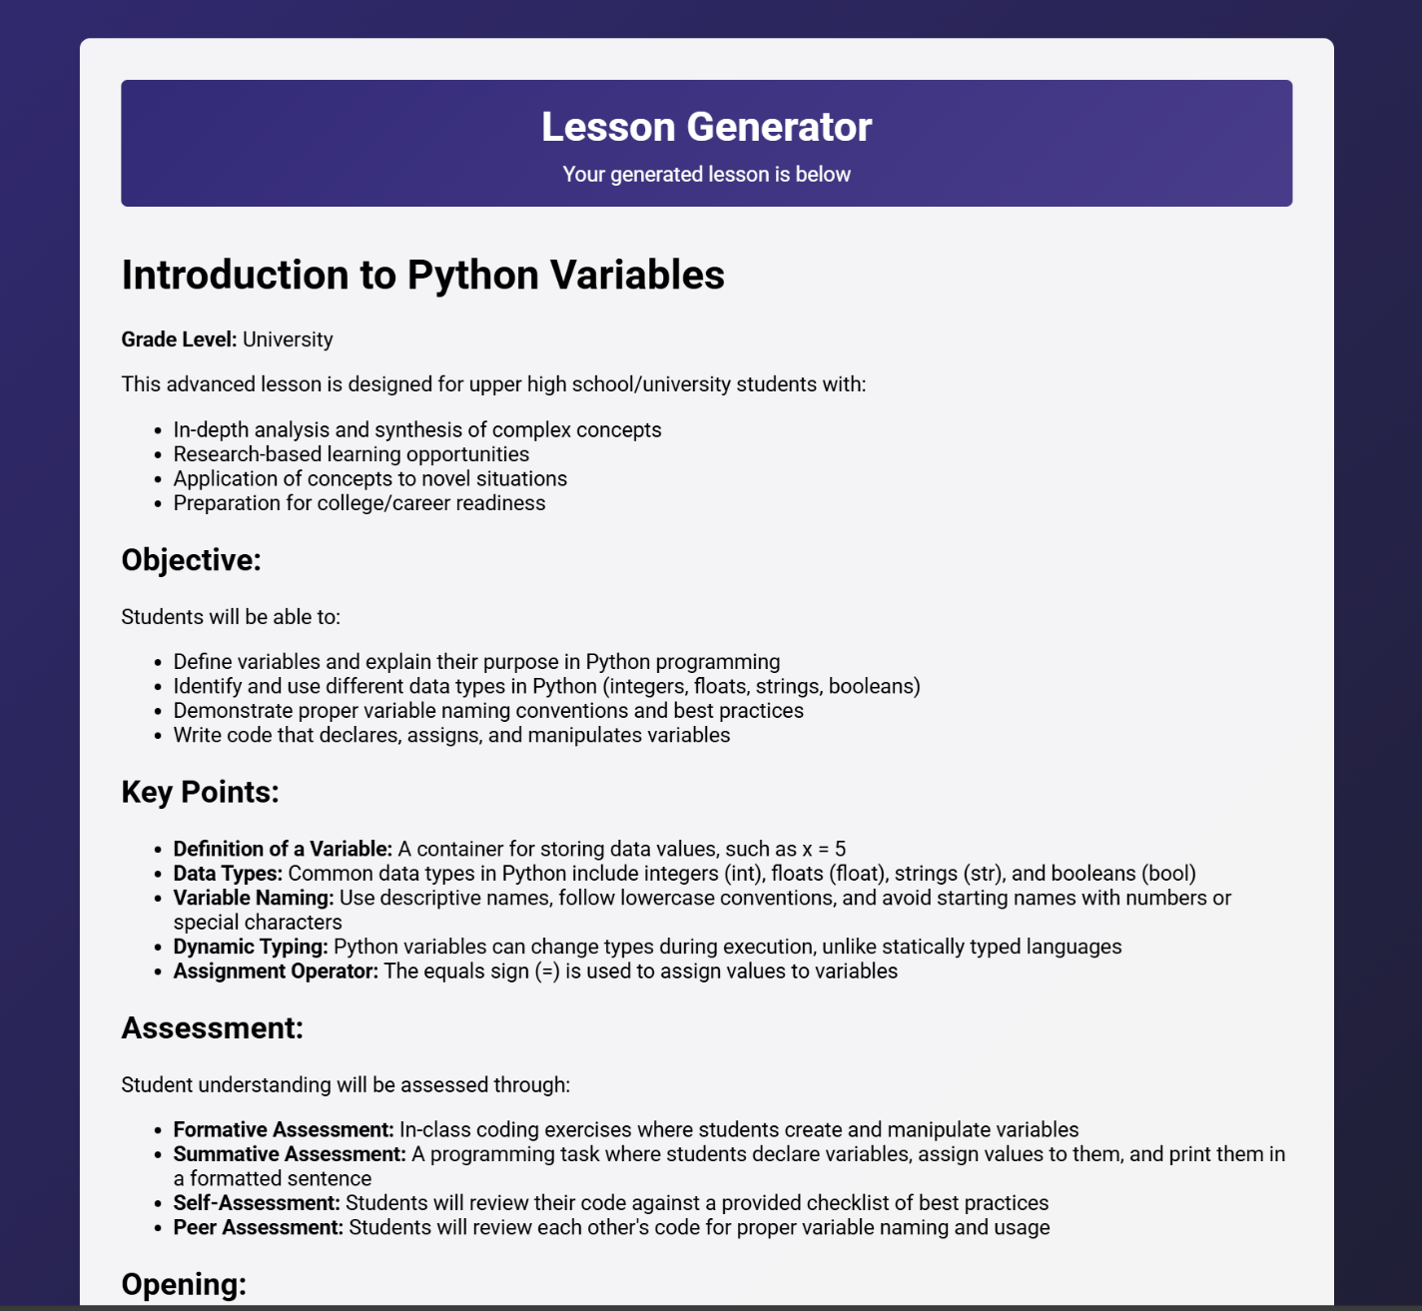

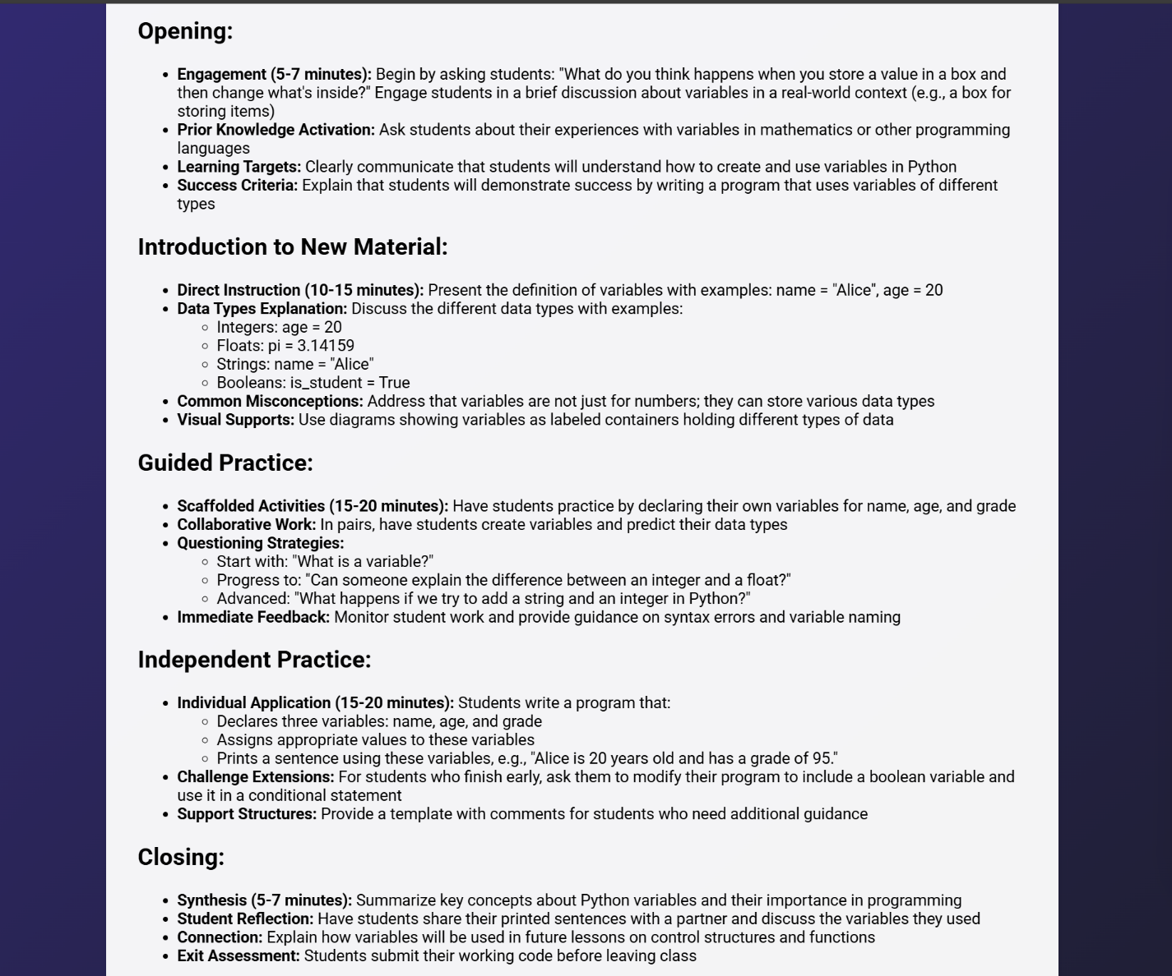

2 buttons on the bottom:

* Download Lesson Plan as DOCX
* Go back to page 1

DOCX file downloading

**lesson_plan.docx**:

* The downloaded **lesson_plan.docx** file includes all the sections for the lesson plan from the generated lesson plan in **lesson_planner_p2.html**.

